CENWP-OD-B 09 July 2023

MEMORANDUM FOR THE RECORD

SUBJECT: 23BON046 MFR WA Shore LPS AWS RB1 Pacific Lamprey Mortality

On the morning of 09 July, Project Biologists discovered one adult Pacific Lamprey mortality in rest box 1 of the Washington Shore Auxiliary Water Supply LPS. (WA-LPS-AWS-RB1). The fish was scanned for PIT tags, inspected, and returned to the river.

- Species – Pacific Lamprey (Entosphenus tridentatus)
- Origin – Unknown
- Length – 60.3 cm
- Marks and tags – None
- Marks and Injuries found on carcass – None
- Cause and Time of Death – Unknown
- Future and Preventative Measures – None

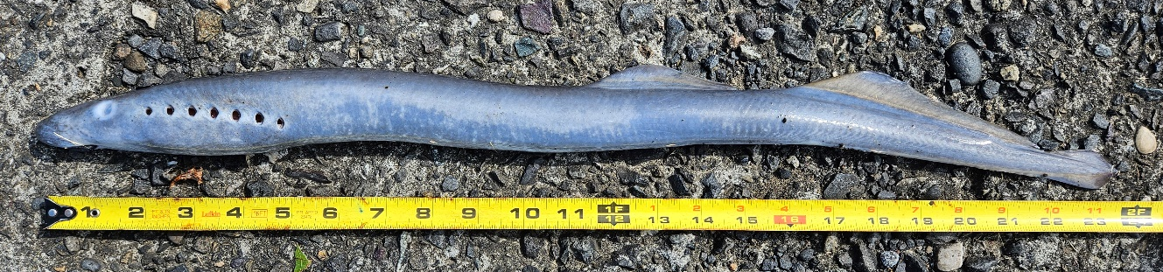
Sincerely,
Bonneville Project Fisheries

